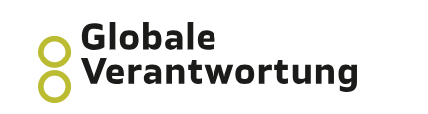
Gender, Diversity and Inclusion in Humanitarian Action
Reading and Video Links

Overview Video:
Save the Children, Humanitarian Capacity Building, Gender Equality in Emergencies, 2017, https://www.youtube.com/watch?v=CSK3D0pTd-s, accessed: 15 October 2023.

Common Issues in humanitarian action:
Gender Associations, Sarah Martin on gender sensitive humanitarian response, 2019, https://www.youtube.com/watch?v=q1lstZZe4BI, accessed: 15 October 2023.

Simon Sinek, What Diversity & Inclusion is REALLY About: Short video about the why, 2021: https://www.youtube.com/watch?v=XisFCRrQivU, accessed: 27 October 2023.

Light for the World, 2022, Intersectionality Factsheet, https://www.licht-fuer-die-welt.at/app/uploads/sites/8/2022/03/Fact-Sheet-on-Intersectionality_Light-for-the-World-2022_Accessible-1.pdf, accessed: 29 October 2023.
Crenshaw, Kimberlé, 2017, Intersectionality and Gender Equality, https://www.youtube.com/watch?v=-DW4HLgYPlA, accessed: 5 November 2023.

Gender, Diversity and Inclusion
Women, Peace and Security and humanitarian action
https://wpshacompact.org/wp-content/uploads/2021/09/WPS-HA-Compact_Framework-EN-Web.pdf accessed on 12th November 2023

South Sudan-NAP -1325, 2015
https://www.undp.org/sites/g/files/zskgke326/files/migration/ss/DLD372-1325-Infosheet_FA5.pdf accessed on 9th November 2023

Diversity, Equality and Inclusion at the IRC, 2021
https://www.rescue.org/sites/default/files/document/5991/irc-deistrategydocr1.pdf accessed on 8th November, 2023

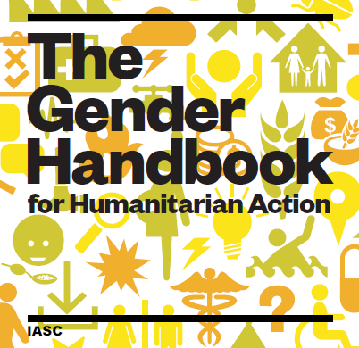
Standards and Guidelines:
The Inter-Agency Standing Committee (IASC) (forum of UN agencies and other partners to strengthen humanitarian assistance) provides guidelines for integrating gender, diversity and inclusion.
IASC Gender Handbook for Humanitarian Action, 2018, https://interagencystandingcommittee.org/iasc-reference-group-gender-and-humanitarian-action/iasc-gender-handbook-humanitarian-action-2018, accessed: 12 October 2023.

IASC Guidelines, Inclusion of Persons with Disabilities in Humanitarian Action, 2019, https://interagencystandingcommittee.org/iasc-guidelines-on-inclusion-of-persons-with-disabilities-in-humanitarian-action-2019, accessed: 12 October 2023.
IASC Gender Handbook Legal Framework
https://www.humanitarianresponse.info/sites/www.humanitarianresponse.info/files/documents/files/Gender%20Handbook%20Legal%20Framework.pdf, accessed on 6 November 2023.

International Federation of Red Cross and Red Crescent Societies, Geneva, 2018, Minimum standards for
protection, gender and inclusion in emergencies, https://www.ifrc.org/sites/default/files/Minimum-standards-for-protection-gender-and-inclusion-in-emergencies-LR.pdf, accessed: 30 October 2023.

Gender Mainstreaming:
UN Women, 2020, Gender mainstreaming: a global strategy for achieving gender equality & the empowerment of women and girls, https://www.unwomen.org/sites/default/files/Headquarters/Attachments/Sections/Library/Publications/2020/Gender-mainstreaming-Strategy-for-achieving-gender-equality-and-empowerment-of-women-girls-en.pdf, accessed: 27 October 2023.

Humanitarian-Nexus-Development:
OXFAM, 2019,The humanitarian-development-peace nexus: what does it mean for multi-mandated organizations?, https://www.alnap.org/help-library/the-humanitarian-development-peace-nexus-what-does-it-mean-for-multi-mandate, accessed: 27 October 2023.

Gender Analysis:
CARE, Gender Emergency Toolkit, https://www.careemergencytoolkit.org/gender/gender-in-emergencies/, accessed: 30 October 2023.
Save the Children, 2013, Rapid Gender Analysis Toolkit, https://resourcecentre.savethechildren.net/document/rapid-gender-analysis-toolkit/

Personal Reflection and Awareness:
Harvard Humanitarian: Implicit Bias Test: https://implicit.harvard.edu/implicit/selectatest.html

Sectors and Topics:

Protection: Save the Children, Humanitarian Capacity Building, Protection in Emergencies, 2017, https://www.youtube.com/watch?v=YWclHizync0, accessed: 15 October 2023.

Interaction, Problem-Solving for Protection in Humanitarian Crises, 2017, https://www.youtube.com/watch?v=zKV1re8cnRc, accessed: 15 October 2023.

Cash Assistance: UN Women, 2019, Guidance Note: How to promote gender equality in humanitarian cash and voucher assistance, https://reliefweb.int/report/world/how-promote-gender-equality-humanitarian-cash-and-voucher-assistance-guidelines-grand, accessed: 15 October 2023.

Water, Sanitation and Hygiene:

WASH Cluster Partners, 2018, WASH Minimum Commitments to Safety and Dignity: framework and tools, https://gbvguidelines.org/en/documents/wash-minimum-commitments-to-safety-and-dignity-framework-and-tools/, accessed: 5 November 2023.

Research and Learning: ALNAP (Active Learning Network for Accountability and Performance) https://www.alnap.org/help-library, accessed: 6 November 2023/

